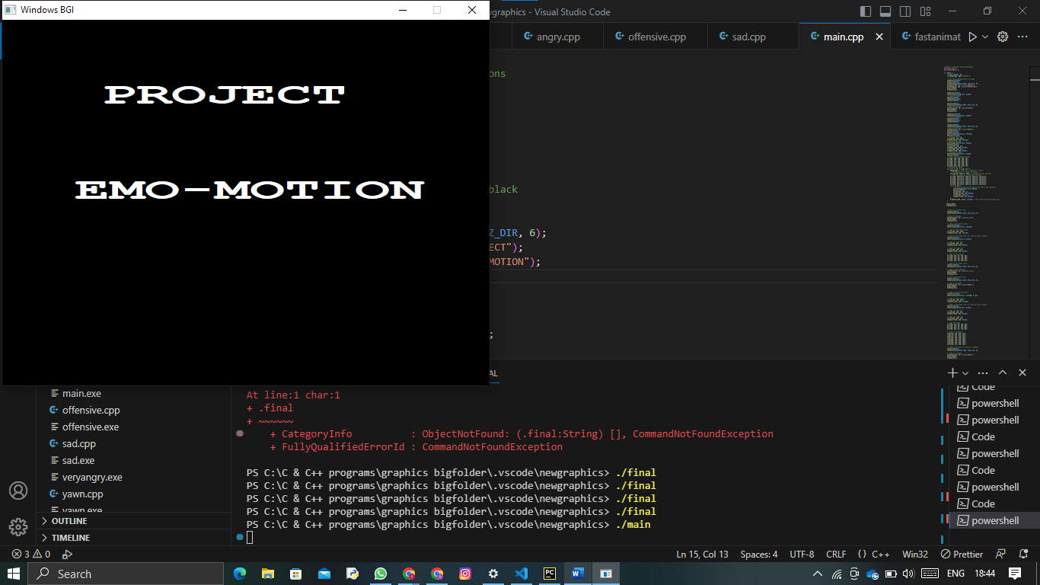

//Code for different emoji expressions

#include<stdio.h>

#include<graphics.h>

int main() {

    int gd = DETECT, gm;

    initgraph(&gd, &gm, (char*)"");

    // Set the background color to black

    setbkcolor(BLACK);

    setcolor(WHITE);

    settextstyle(DEFAULT_FONT, HORIZ_DIR, 6);

    outtextxy(130, 75, (char*)"PROJECT");

    outtextxy(95, 200, (char*)"EMO-MOTION");

    delay(3000);

    cleardevice();

    setbkcolor(BLACK);

    setfillstyle(SOLID_FILL, BLACK);

    // setcolor(BLACK);

    setcolor(BLACK);

    setbkcolor(BLACK);

    setcolor(WHITE);

    setcolor(WHITE);

    settextstyle(DEFAULT_FONT, HORIZ_DIR, 6);

    //Code for heading

    outtextxy(135, 35, (char*)"HAPPY");

    delay(1500);

    cleardevice();

    setbkcolor(BLACK);

    setfillstyle(SOLID_FILL, BLACK);

    // setcolor(BLACK);

    setcolor(BLACK);

    setbkcolor(BLACK);

    setcolor(WHITE);

    setcolor(WHITE);

    settextstyle(DEFAULT_FONT, HORIZ_DIR, 6);

    //Code for heading

    outtextxy(135, 35, (char*)"HAPPY");

    setcolor(BLACK);

    setcolor(BLACK);

    setfillstyle(SOLID_FILL, YELLOW);

    setcolor(YELLOW);

    // Drawing the face

    circle(250, 250, 150);

    floodfill(250, 250, YELLOW);

    // Drawing the eyes

    setfillstyle(SOLID_FILL, BLACK);

    setcolor(BLACK);

    circle(200, 200, 21);

    floodfill(200, 200, BLACK);

    circle(300, 200, 21);

    floodfill(300, 200, BLACK);

    // Drawing the mouth

    setfillstyle(SOLID_FILL, BLACK);

    setcolor(BLACK);

    // Draw initial mouth position

    arc(250, 280, 220, 320, 70);

    arc(250, 279, 220, 320, 70);

    arc(250, 278, 220, 320, 70);

    arc(250, 277, 220, 320, 70);

    arc(250, 281, 220, 320, 70);

    arc(250, 282, 220, 320, 70);

    // Animate the mouth

    for (int i = 0; i < 20; i++) {

        delay(100); // Wait for a tenth of a second

    //    cleardevice(); // Clear the screen

        circle(250, 250+i/2, 150); // Redraw the face and eyes

        // Draw the mouth in a different position

        arc(250, 280-i*2/3, 220+i/6, 320-i/6, 70+i*3/4);

        arc(250, 279-i*2/3, 220+i/6, 320-i/6, 70+i*3/4);

        arc(250, 278-i*2/3, 220+i/6, 320-i/6, 70+i*3/4);

        arc(250, 277-i*2/3, 220+i/6, 320-i/6, 70+i*3/4);

        arc(250, 281-i*2/3, 220+i/6, 320-i/6, 70+i*3/4);

        arc(250, 282-i*2/3, 220+i/6, 320-i/6, 70+i*3/4);

        if (i == 19) {

            // little twinkle in the eye at the end of the animation

            setfillstyle(SOLID_FILL, WHITE);

            setcolor(WHITE);

            circle(195, 195, 7);

            floodfill(195, 195, WHITE);

            circle(305, 195, 7);

            floodfill(305, 195, WHITE);

        }

        floodfill(250, 250+i, YELLOW); // Fill the face with yellow color

    }

   delay(3200);

   cleardevice();

    //Code to set black color

    setcolor(WHITE);

    settextstyle(DEFAULT_FONT, HORIZ_DIR, 6);

    //Code for heading

    outtextxy(135, 35, (char*)"S A D");

    delay(1500);

    cleardevice();

    // Code to set yellow color

    setcolor(YELLOW);

    setfillstyle(SOLID_FILL, YELLOW);

    // Code to draw face circle

    circle(250, 250, 150);

    floodfill(250, 250, YELLOW);

    // Code to set black color for eyes as well as mouth

    setcolor(BLACK);

    setfillstyle(SOLID_FILL, BLACK);

    // Code for left eye

    circle(200, 200, 10);

    floodfill(200, 200, BLACK);

    // Code for right eye

    circle(300, 200, 10);

    floodfill(300, 200, BLACK);

    // Code for sad mouth

    arc(250, 365, 40, 140, 80);

    arc(250, 364, 40, 140, 80);

    arc(250, 363, 40, 140, 80);

    arc(250, 362, 40, 140, 80);

    // Code to set black color

    setcolor(WHITE);

    settextstyle(DEFAULT_FONT, HORIZ_DIR, 6);

    // Code to draw heading

    outtextxy(135, 35, (char*)"S A D");

    delay(2000);

    cleardevice();

    //Code to set black color

    setcolor(WHITE);

    settextstyle(DEFAULT_FONT, HORIZ_DIR, 6);

    // Code for heading

    outtextxy(135, 35, (char*)"ANGRY");

    delay(1500);

    cleardevice();

    // Code to set yellow color

    setcolor(YELLOW);

    setfillstyle(SOLID_FILL, RGB(200, 0, 0));

    // Code for face circle

    circle(250, 250, 150);

    floodfill(250, 250, YELLOW);

    // Code to set black color for eyes as well as mouth

    setcolor(BLACK);

    setfillstyle(SOLID_FILL, BLACK);

    // Code for left eye

    circle(200, 200, 10);

    floodfill(200, 200, BLACK);

    // Code for right eye

    circle(300, 200, 10);

    floodfill(300, 200, BLACK);

    // Code for mouth

    arc(250, 365, 40, 140, 80);

    arc(250, 364, 40, 140, 80);

    arc(250, 363, 40, 140, 80);

    arc(250, 362, 40, 140, 80);

    // Code for eyebrows

    line(170, 159, 220, 179);

    line(170, 160, 220, 180);

    line(170, 161, 220, 181);

    line(170, 162, 220, 182);

    line(280, 179, 330, 159);

    line(280, 180, 330, 160);

    line(280, 181, 330, 161);

    line(280, 182, 330, 162);

    // Code to set color to black for heading

    setcolor(WHITE);

    settextstyle(DEFAULT_FONT, HORIZ_DIR, 6);

    // Code for heading

    outtextxy(135, 35, (char*)"ANGRY");

    delay(2000);

    cleardevice();

     // Code for setting color to black

    setcolor(WHITE);

    settextstyle(DEFAULT_FONT, HORIZ_DIR, 6);

    // Draw heading

    outtextxy(55, 35, (char*)"OFFENSIVE");

    delay(1500);

    cleardevice();

    // Code to set color to yellow

    // setcolor(YELLOW);

    setcolor(YELLOW);

    setfillstyle(SOLID_FILL, RGB(200, 0, 0));

    // Code for face

    circle(250, 250, 150);

    floodfill(250, 250, YELLOW);

    // Code to set black color for eyes as well as mouth

    setcolor(BLACK);

    setfillstyle(SOLID_FILL, BLACK);

    // Code for left eye

    circle(200, 200, 10);

    floodfill(200, 200, BLACK);

    // Code for right eye

    circle(300, 200, 10);

    floodfill(300, 200, BLACK);

    // Code for mouth

    arc(250, 365, 40, 140, 80);

    arc(250, 364, 40, 140, 80);

    arc(250, 363, 40, 140, 80);

    arc(250, 362, 40, 140, 80);

    // Code to draw angry eyebrows

    line(170, 159, 220, 179);

    line(170, 160, 220, 180);

    line(170, 161, 220, 181);

    line(170, 162, 220, 182);

    line(280, 179, 330, 159);

    line(280, 180, 330, 160);

    line(280, 181, 330, 161);

    line(280, 182, 330, 162);

    // Code to set color to black

    setcolor(WHITE);

    settextstyle(DEFAULT_FONT, HORIZ_DIR, 6);

    // Code for heading

    outtextxy(55, 35, (char*)"OFFENSIVE");

    // Code to set color to black

    setcolor(WHITE);

    settextstyle(DEFAULT_FONT, HORIZ_DIR, 6.9);

    // settextjustify(TRIPLEX_FONT,)

    outtextxy(137, 282, (char*)"!#%&$");

    delay(2000);

    cleardevice();

    // Set the background color to black

    setbkcolor(BLACK);

    setcolor(WHITE);

    settextstyle(DEFAULT_FONT, HORIZ_DIR, 3);

    outtextxy(15, 75, (char*)"PROJECT BY:-");

    outtextxy(15, 175, (char*)"22BAI1403 - SHANTANU WANI");

    outtextxy(15, 250, (char*)"22BAI1119 - YAHYA KHWAJA");

    delay(5000);

    // cleardevice();

    closegraph();

    return 0;

}